***Description: cd 120Col***

**www.customerdiagnostics.co.za**



**WORLD CAFE**

**WesBank Corporate IT**

**24 Aug 2018**

**Facilitated by:**

**Alan Kirschner**



PO Box 899, Fourways, Sandton, 2055

Telephone: (011) 465-5182

Email: [alan@customerdiagnostics.com](mailto:alan@customerdiagnostics.com)

The Achievement Model, Achievement Process and

Achievement Profiles are reproduced under licence

with the kind permission of the Achievement Network Ltd.

**The Delegates:**

|  |  |  |  |  |  |
| --- | --- | --- | --- | --- | --- |
| **Name** | **Surname** | **Email address** | **Designation** | **Team** | **Attending** |
| Amanda | Mjoli | [Amanda.Mjoli@wesbank.co.za](mailto:Amanda.Mjoli@wesbank.co.za) | Head of BA | Business Analysis Team | Y |
| Bigboy | Madihlaba | Bigboy.Madihlaba@wesbank.co.za | Developers | Development Team | Y |
| Busisiwe | Simelane, | Busisiwe.Simelane@wesbank.co.za | Business Analyst | Business Analysis Team | N |
| Candis | Singh | Candis.Singh@wesbank.co.za | Developers | Development Team | Y |
| Edwin | Matodzi | Edwin.Matodzi@wesbank.co.za | Head of SA | System Analyst Team | Y |
| Gangatha | Mkele | GMkele@wesbank.co.za | Development Team leader | Development Team | N |
| Gordon | Marriday | [GMarriday@wesbank.co.za](mailto:GMarriday@wesbank.co.za) | Head of SM | Service management | Y |
| Grant | Beattie | GBeattie@wesbank.co.za | Project Manager | Motor Project Management Office | Y |
| Ian | Wegerle | IWegerle@wesbank.co.za | Developers | Development Team | Y |
| Innocent | Gumede | IGumede@wesbank.co.za | Development Team leader | Development Team | Y |
| Isaac | Makota | IMakota@wesbank.co.za | Developers | Development Team | Y |
| Johan | Thomas | [JThomas@wesbank.co.za](mailto:JThomas@wesbank.co.za) | CRO |  | Y |
| Johan | Wilters | JWilters@wesbank.co.za | Business Analyst | Business Analysis Team | Y |
| Jonathan | Tak | JTak@wesbank.co.za | Testers | Quality Assurance Team | Y |
| Keagile | Tlabakwe | KTlabakwe1@wesbank.co.za | Developers | Development Team | Y |
| Leeto | Modutoane | Leeto.Modutoane@wesbank.co.za | System Analyst | System Analyst Team | Y |
| Lindiwe | Mhlongo | LMhlongo@wesbank.co.za | Testers | Quality Assurance Team | Y |
| Mandla | Mtombeni | Mandla.Mtombeni@wesbank.co.za | Developers | Development Team | Y |
| Martha | Ndlovu | Martha.Ndlovu@wesbank.co.za | Business Analyst | Business Analysis Team | Y |
| Matikita | Abel Mphahlele | MMphahlele1@wesbank.co.za | Testers | Quality Assurance Team | Y |
| Mbali | Madonsela | MMadonsela@wesbank.co.za | Developers | Development Team | Y |
| Mkhululi | Mkhwanazi | Mkhululi.Mkhwanazi@wesbank.co.za | Testers | Quality Assurance Team | N |
| Mmule | Lebeloane | Mmule.Lebeloane@wesbank.co.za | Project Managers | Project Management Team | Y |
| Molefi | Moeketsi | Molefi.Moeketsi@wesbank.co.za | Head of Dev & Sol Arc | Development Team | Y |
| Nenzeni | Duma | [NDuma@wesbank.co.za](mailto:NDuma@wesbank.co.za) | WesBank CIO |  | Y |
| Nick | Brown | NBrown@wesbank.co.za | Programme Manager | Motor Project Management Office | Y |
| Ntombie | Matiwane | Ntombie.Matiwane@wesbank.co.za | Project Managers | Project Management Team | Y |
| Phambili | Mzaca | Phambili.Mzaca@wesbank.co.za | Business Analyst | Business Analysis Team | N |
| Ricco | Stevens | RStevens1@wesbank.co.za | System Analyst | System Analyst Team | Y |
| Sammy | Mmamabolo | Sammy.Mmamabolo@wesbank.co.za | Head of ops | Operations | Y |
| Sandy | Naidoo | SNaidoo4@wesbank.co.za | Testers | Quality Assurance Team | N |
| Sane | Mncwabe | Sane.Mncwabe@wesbank.co.za | Project Managers | Project Management Team | N |
| Selogilwe | Tlhale | Selogilwe.Tlhale@wesbank.co.za | Service Manager | Operations | Y |
| Sibongile | Ndlovu | NdlovuSibongile@wesbank.co.za | Head of PM | Project Management Team | Y |
| Sinegugu | Ndimeni | [Sinegugu.Ndimeni@wesbank.co.za](mailto:Sinegugu.Ndimeni@wesbank.co.za) | SD Manager | Solution Delivery | Y |
| Sisanda | Tiso | [Sisanda.Tiso@wesbank.co.za](mailto:Sisanda.Tiso@wesbank.co.za) | QA Manager | Quality Assurance Team | Y |
| Stanley | Pimenta | SPimenta@wesbank.co.za | Business Analyst | Business Analysis Team | Y |
| Thabisa | Newman | [Thabisa.Newman@wesbank.co.za](mailto:Thabisa.Newman@wesbank.co.za) | Project Support Officer | Project Management Team | Y |
| Themba | Sivate | Themba.Sivate@wesbank.co.za | Developers | Development Team | Y |
| Thokozile | Mapumulo | [TMapumulo@wesbank.co.za](mailto:TMapumulo@wesbank.co.za) | Business Analyst | Business Analysis Team | Y |
| Thulani | Sibeko | Thulani.Sibeko@wesbank.co.za | Project Managers | Project Management Team | Y |
| Tshepiso | Ratselane | Tshepiso.Ratselane@wesbank.co.za | Operations Manager | Operations | Y |
| Victor | Ngoato | VNgoato@wesbank.co.za | Developers | Development Team | Y |
| Waldo | Wolmarans | WWolmarans@wesbank.co.za | Developers | Development Team | Y |
| Werner | Saayman, | Werner.Saayman@wesbank.co.za | Business Analyst | Business Analysis Team | Y |
| Yolandi | Havenga | [Yolandi.Havenga@wesbank.co.za](mailto:Yolandi.Havenga@wesbank.co.za) |  |  | Y |

**Agenda**





**Welcome and opening by Edwin**

Thank you, Alan, for organising this session.

Welcome everyone and thank you very much for your willingness to participate – and also thank you to those who managed to complete the pre-work.

Today is an opportunity for us to reflect on the progress we have made in our project. This is the question I would like us to reflect on today. Is it sustainable, can we continue this way? For all of us here, I would like us all to talk about it, be open about it, so that we can move forward as a team.

We spend 8 hours or more every day at our offices at WesBank. Can we do more with the time there working with each other? How can we help each other to help ourselves in these office hours? I would like us to reflect on this today.

We all have the ability and accountability to run the bank. The entire bank is built upon and into the systems that we are running. If for some reason one of the systems is down, do we have any idea what the impact will be on the bank?

So today we need to reflect on, and be aware of, our environment and the bank.

**Context and Purpose of the workshop by Nenzeni**

With that Edwin, thank you.

You asked me to talk about team work and regulatory compliance, but I also want to add a third thing which is about the strategic context of what we do, and how we have to ask ourselves the question which is strategically, what are we doing, and how is it important.

Let me ask the question – let’s say the regulators have a piece of regulation and we as FirstRand, FNB, WesBank have to conform. What happens to our licence to operate as a bank if we don’t conform? We cannot operate as FirstRand. That is the weak link in a strong link – and that is how important each person’s role is not only to WesBank, not only to a specific team , but to the rest of FirstRand. If FirstRand can’t operate, what happens to our customers and the economy of SA, because we play a very important role as one of the leading banks in the country. South Africa is known globally for its strength of governance and that is because of the regulations and how we comply to those regulations. So when we don’t comply, we put WesBank at risk, we put FirstRand at risk, and we put our economy at risk, and that is not an exaggeration. So when we take time for interventions such as today it is really serious. Not just to have a great day out of the office but to allow us to think outside the box. We need to make a significant change to the way we operate.

The other item is around teamwork and this is well timed because in August we all got our increases and bonuses. So ask yourself what is going to happen if we continue to deliver in this way. Should we even get our bonuses should we continue to deliver in this way?

So the teamwork is important and it is not around saying “I have to wait for my manager to tell me what to do today”. Self-managing teams and self-organising teams will anticipate the need, and pull everyone together. We need a significant shift from the way that we are currently working. In the past it was okay and it was accepted by our shareholders at FirstRand – if you delivered anywhere between 15% and 18% return on capital is was okay. Our business is capital intensive – it is built for sales and volume. So what was okay to do in the past, the shareholders now, based on the new FirstRand operating model, are now saying ‘that’s not enough’. What we have to do now is bring in a lot more value in terms of delivering our value as WesBank. So that is why, when we set our purpose around stabilising the environment, pumping in so much volume, getting the basics right, it was so that we can at least have the growth that we have targeted. To do this, we don’t do it as individuals.

So I want you to consider the strategic context and ask yourself every single day when you come to the office: “Is what I am doing now contributing to the strategic focus?”. There is no room anymore for any one of us to sit back and say ‘someone else is going to do it’.

We are at a point where we are fighting for our place in the industry and within FirstRand. Before we could say that other competitors were not good enough; but guess what, they have all woken up and they are sucking the good customers (A1,2, 3) into their custody.

So when we don’t deliver profits in a positive way they, our customers, just leave. So what we have to do now is fight tooth and nail for the customers that we have, not to lose even one; and then we need to make sure that the customers with the other banks become FirstRand customers. That is what the shareholder is looking for us to do.

So let’s just think what is happening from an individual and team leadership perspective and what changes we need to make with this intervention today; changes on a daily basis. Remember it takes about 6 months to change a habit, so rather do it every single day for these changed behaviours to be a habit.

With that, Alan, thank you for the opportunity. I wish you all a really great day. There are no egos and not titles here today, this is just the team and we are looking for solutions to work well together from you today. You must hold each other accountable.

**Handover to Alan from Customer Diagnostics (Pty) Ltd**

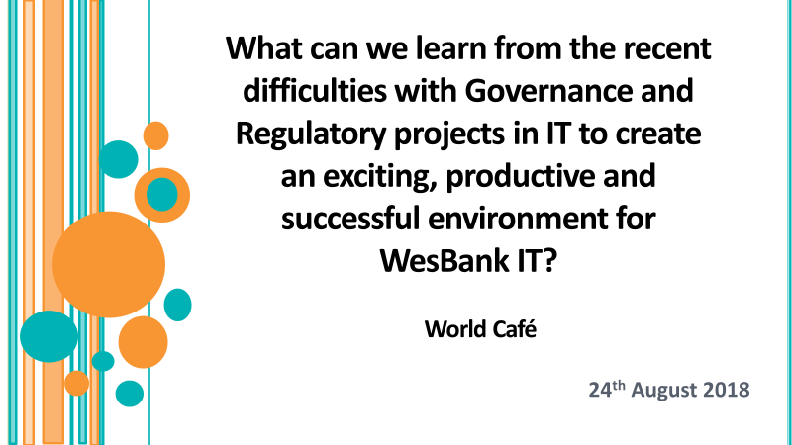



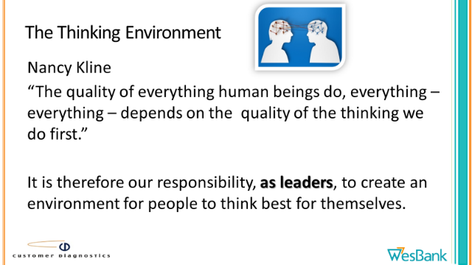

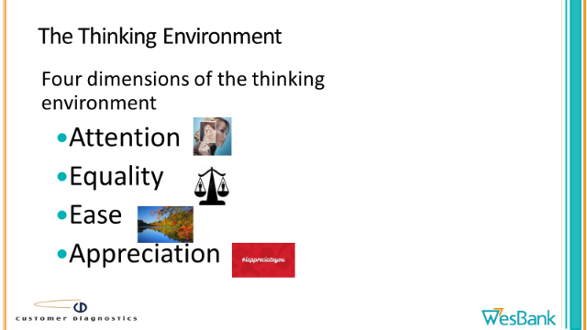

**Hopes**

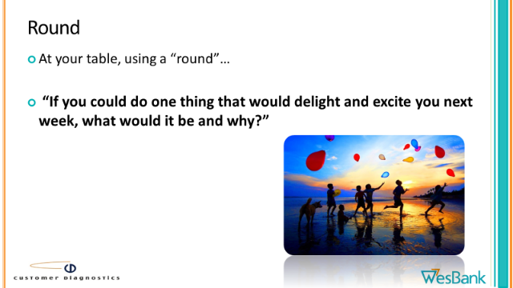

1. To learn something – e.g. good processes / what went wrong?
2. A high level of participation & engagement.
3. Relationship building.
4. To take accountability.
5. To share ideas.
6. Action plans.
7. Leave with a positive attitude.
8. Collaboration & synergy.
9. Enlightened on the attributes of self-directed teams.

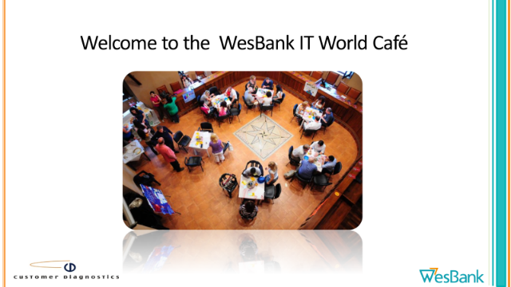

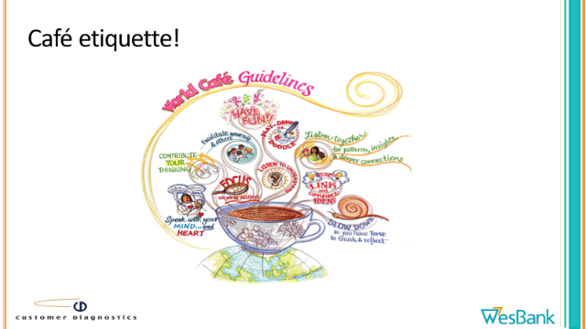

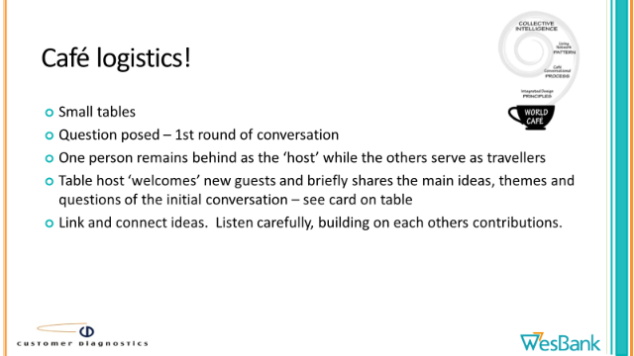

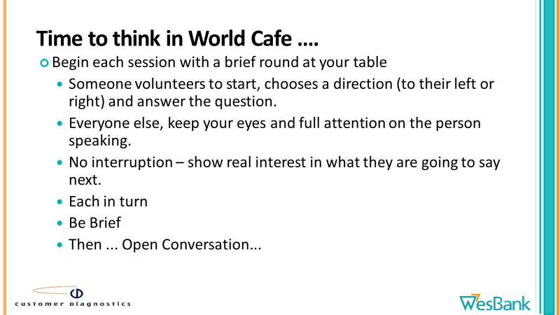



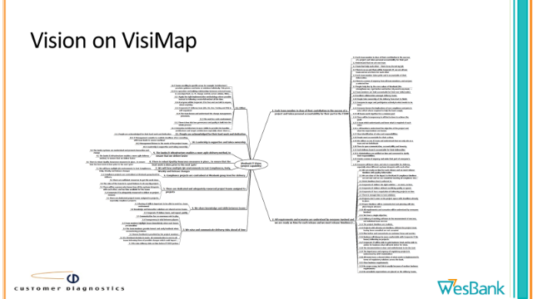

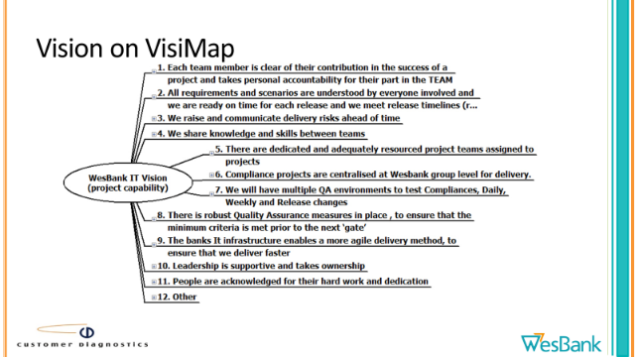

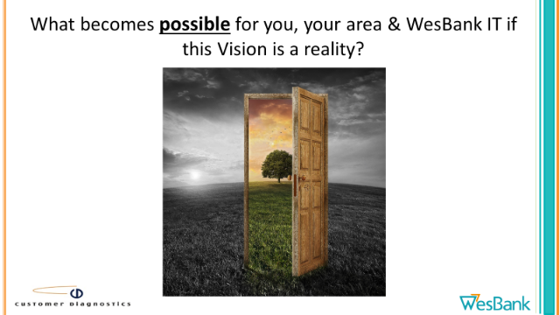

**What becomes possible for you, your area & WesBank IT if this Vision is a reality?**

**Debrief**

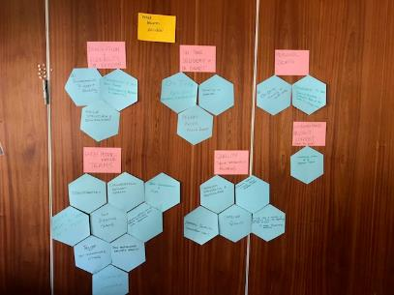

**Innovation & Flexibility to explore**

* Environment to support flexibility
* Flexibility to try new things (exploration, innovation & creativity)
* Agile structure & environment

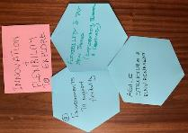

**High performance Teams**

* Transparency
* Move from a Group to a ~Team
* Self-directing teams
* Collaboration between teams
* Team collaboration & fun
* Becoming partners & not service providers allows better collaboration
* High performance delivery teams
* Trust & not undermining each other
* Meaningful contribution

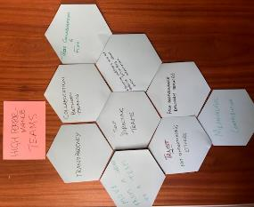

**On-time delivery & in budget**

* On time delivery by individual, Team & WesBank
* Deliver faster & within budget
* Delivering on promises

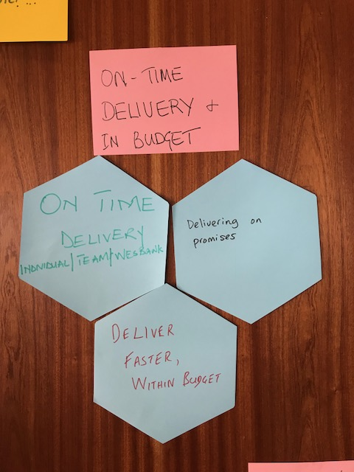

**Quality (defined standards & procedures)**

* Defined standards and procedures
* Quality measure – clearly defined successful criteria
* Improved quality (Individual, Team, Vehicle & Asset Finance (VAF))
* With clear and realistic expectations from the beginning of the project = less frustration & conflict.

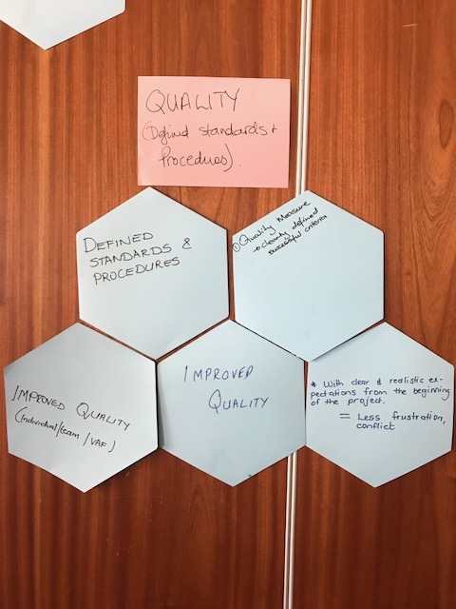

**Understand project context**

* Understand context of all business projects

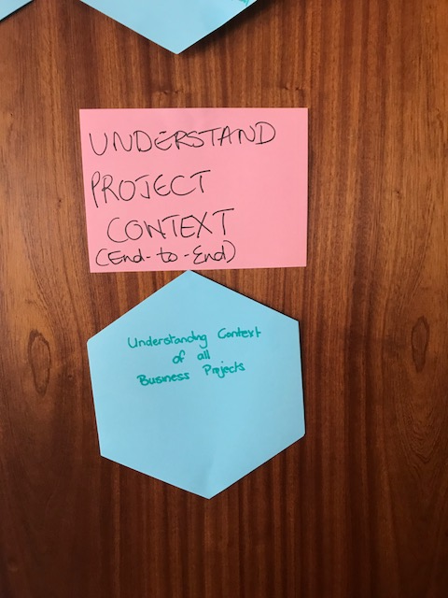

**Personal growth**

* Ongoing training to build skills
* Opportunity to grow
  + Know & participate in different parts of the domain i.e. strategy, tactical

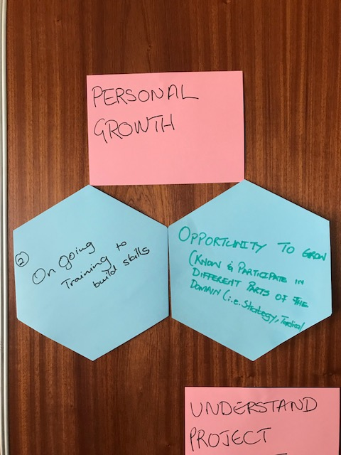

**Assessing: Our current Reality**

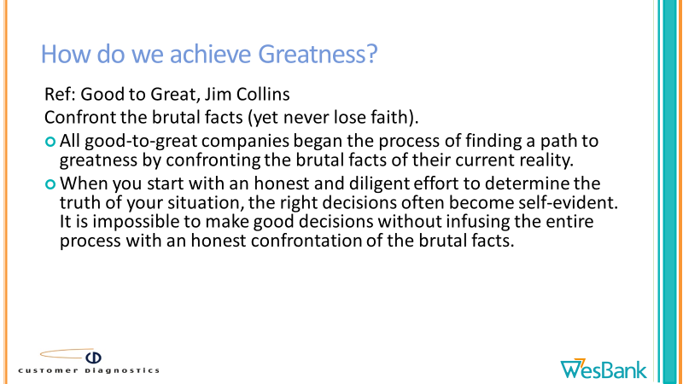

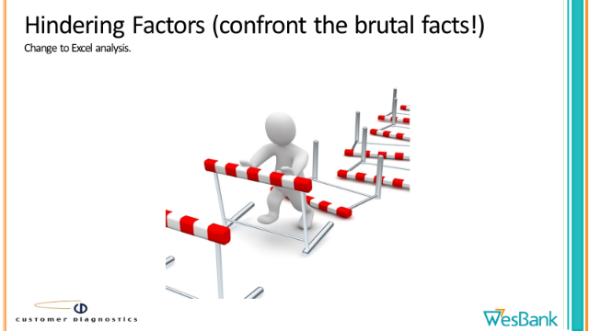

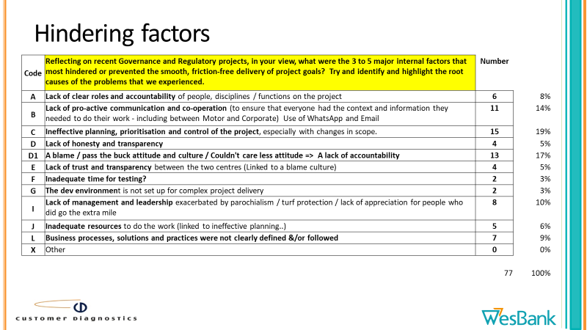



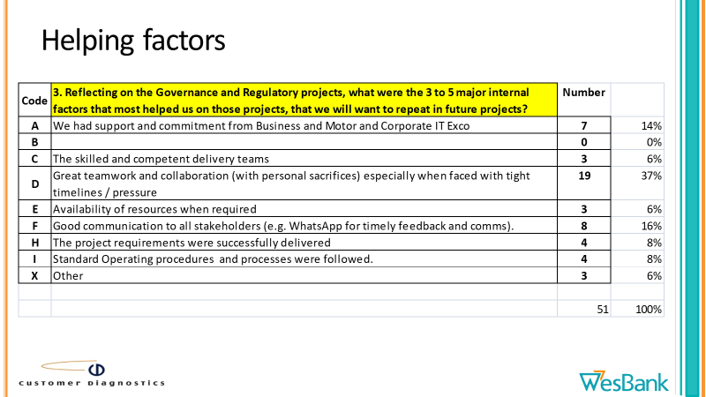

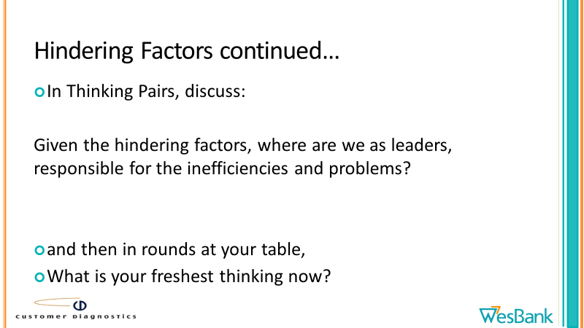

**Where are we as leaders, responsible for the inefficiencies and problems?**



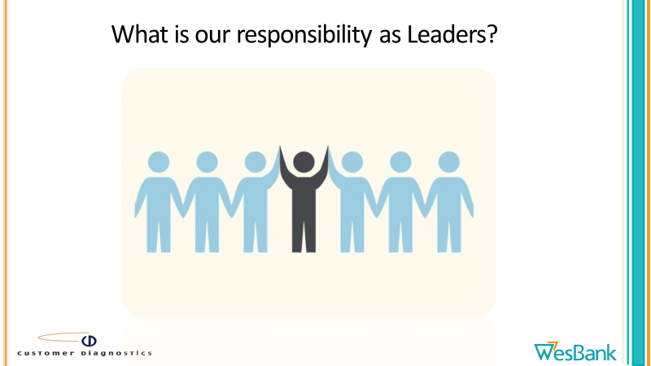

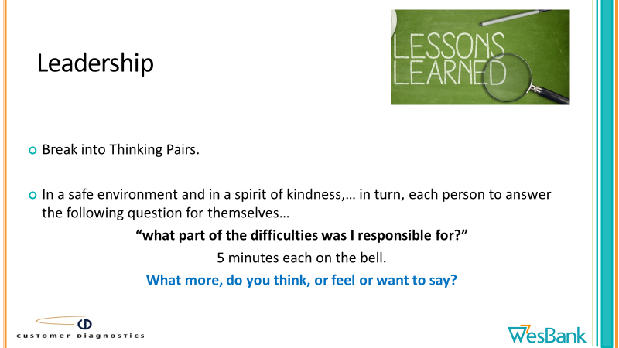

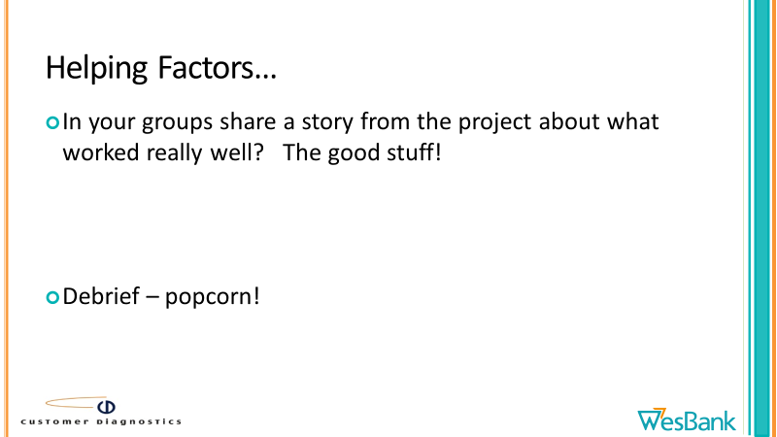

**Stories from the project that worked really well.**

1. Performance testing – assistance from Isaac – although he was not part of the project he assisted us a lot.
2. Gordon came in and pulled the team together – he was not part of Corporate IT.
3. Highlight the role that Isaac played, he was with us throughout the project. She said we are like runners, when our lives are in danger. We are very resourceful when we are under pressure.

**What are the Real Issues?**

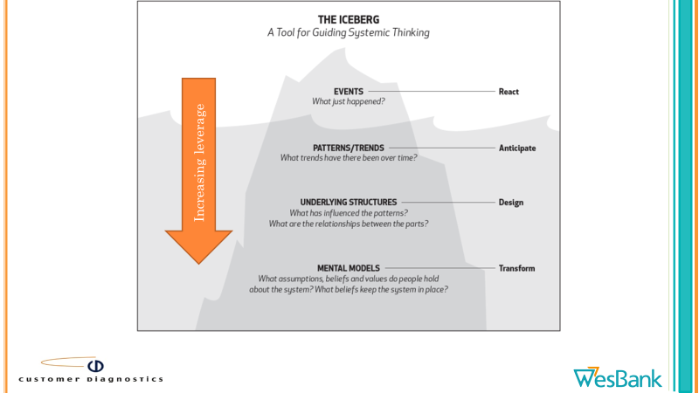

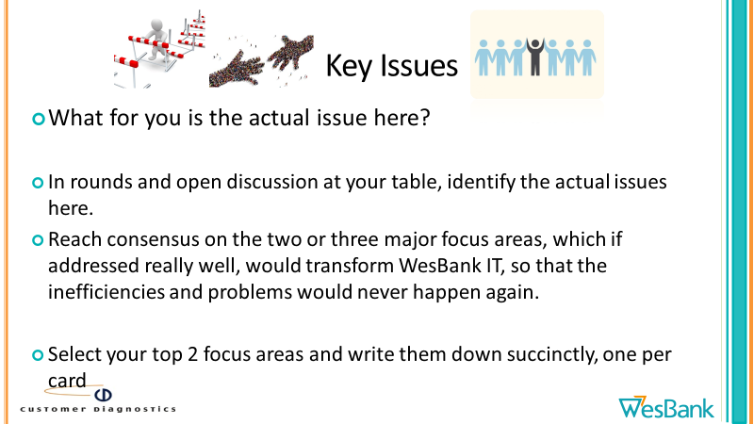

**Regulatory discussion by Johan Thomas**

Thanks for the invitation. This is something that is very close to my heart.

What you are doing from an IT perspective is very important, as a lot of the things that we do from a regulatory perspective we cant do and implement in the Bank without the IT community.

I am not sure what all the stuff was that you had already unpacked this morning, around what has gone well and the areas that need some improvement in these projects. I think in my mind from a banking perspective when the Reserve bank issues new legislation, that legislation needs to come into our Banking environment and the Banks need to comply with those requirements.

When this legislation comes into the FirstRand world, it is unpacked by the specialists to see what this means for us as an organisation and within that organisation how does that filter down into the different Brands.

In WesBank we are an accountable institution on our own, as FNB, RMB, so we need to unpack and distil this legislation in our minds and see how this impacts our business models.

We have gone through the federated models, I joined in Jan2016, we started federating this business from a WesBank Group perspective. I think the place we went wrong is with the regulatory compliance projects. We started federating on the corporate side, by process of design I hope we will end up at the same road.

IT regulations in our world is so critical because that allows us to have and keep our banking licence.

We have to take what is done in FirstRand, we need to see how this legislation impacts our business on a day to day basis.KYC, FIC – there is 8 risk people sitting around the table, we need to get business closer to Risk Implementation. There is a reliance in the regulatory space from each person in the compliance & risk space.

Challenge: Deadlines from the regulator.

**Example**:

NCA regulation (13 April 2018) they just said we needed to be compliant from 14 April 2018. Any deals that is done from the 14 April – the bank is non-compliant. We were doing business as usual, whilst the NCA was in effect.

How easy was the change from 14% VAT to 15% VAT?

All our agreements need to be changed, systems needed to be replaced, GL’s were impacted. It was not an easy change.

KYC Remediation cost the FirstRand Group R600million. FIC will be landed Feb 2019.

All of us that touch data, customers, paper – we have a role to play, where every person has an impact on the correctness of information on the database.

You play a critical role from where we get the new regulations to how we get this implemented into the business. Small changes create huge pressures.

Regulations in our world is why we have a banking licence. We attract depositor’s money and we lend it out to customers – that is how we make money.

We get legislation – Wynand looks at upcoming legislation, we need to feed that information into the IT world, in order for you to pre-empt the changes required.

**Lessons learnt:**

We have to be one voice in whatever we tackle. There are systems that go across the business. It is dovetailing our resources in order to create synergies in the business.

Session like the one you are having is very valuable in order to try and understand how our worlds fit into one another.

From a FirstRand point of view, we speak with WesBank a lot. When the NCA was written the draft came out and there was a lot of lobbying from FirstRand into the regulator. We try and understand where things are going from the regulatory point of view.

Papaya – has not been implemented yet. But a lot of concepts around this legislation we have been using and has been requirements for a while. We have to have one view of this world called regulations.

**Do we understand the risks that sit in the IT world?**

I feel that we have not been great at understanding IT risk.

Understanding the interdependency that IT risk has across the businesses. If the chassis is not built properly – it will fall apart.

**How do we ensure that Business takes responsibility and accountability and start attending risk meetings?**

We as risk practitioners need to step away and need to give the responsibility to the business people to take accountability. They must understand what the impacts of these risks in their businesses are.

I invite you to email us if you have questions, or invite us to meetings if you need us to get involved in order for us to explain risk to you.

You need to understand why you are doing things and what the impact is for the business.

**Debrief of Focus Areas**

**WesBank Corporate IT Key Focus Areas**



1. **Proper planning**
   1. Realistic timelines
   2. Quality vs quantity
   3. Commit to collectively agreed delivery dates
   4. Ensure clearly defined requirements
   5. Involvement
2. **Creating a culture of Ownership & Teamwork**
   1. It's not my part - attitude – ownership
   2. Speak up
   3. Transparency
   4. Ownership
   5. Breaking silos and creating cohesiveness across the teams
   6. Engagement model for cross functional teams to be clear
3. **Comprehensive ongoing communication at all levels**
   1. Better communication within WesBank Group

**Voting for Focus Areas**

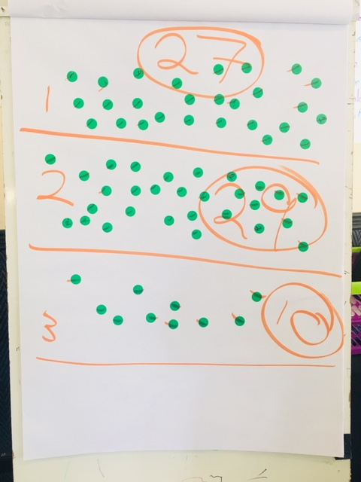

**Focus Area 1: Creating a culture of ownership & teamwork**

**Definitions of success:**

1. Everyone knows what their role is and takes full accountability for it.
2. Proactive communication
   1. People feel safe to speak up and are listened to.
   2. The IT community have an understanding of business requirements and needs.
   3. All stakeholders are aware of what is happening in the environment.
3. We feel collectively responsible for the success of our projects.ie each member is fully and equally invested in the success of the project.
4. There is mutual respect for each other including their competencies and capabilities. There is a culture of trust and interdependence especially at the interfaces.
5. There is a culture of collaboration during the entire lifecycle, not only when there is a crisis.
6. We move as one & speak with one voice.
7. We deliver our projects on time, in budget and with an absence of chaos – with built in quality.
8. Happy business stakeholders.
9. We retain our banking licence.

**Action Plans**

|  |  |  |
| --- | --- | --- |
| **Action** | **By whom** | **By when** |
| 1. Develop a detailed plan to create standard operating procedures on a prioritised basis for all our IT business processes (including a clear RACI & clarity on roles & responsibilities) This must align with the SDLC processes that are currently being reviewed. Present to the Corporate IT Exco for approval. | Sinegugu | 30 Sep 2018 |
| 1. Involve the people doing the work in project planning and project team meetings. With the help of the project manager. The actual resources doing the work will be specified in the project plan. Start immediately with the projects currently under execution. | Sinegugu | Ongoing |
| 1. Create a project dashboard which shows the status of all current IT work and make it available on the sharepoint site. | Sibongile | 31 Aug 2018 |
| 1. Build in a teamwork objective into our performance contract. | Edwin | 31 Mar 2019 |
| 1. Develop an IT engagement model for business. | Amanda | 31 Oct 2018 |
| 1. We conduct evaluations for all projects, immediately after the projects as part of the learning & improvement process i.e. not punitive. Lessons are fed back into other projects. | Sibongile | 31 Oct 2018 |
| 1. Conduct an annual customer satisfaction survey, the results of which will be fed into each individual’s performance contract. Present a proposal to IT Exco for approval. | Amanda | 28 Feb 2019 |
|  |  |  |

**Focus Area 2: Proper planning**

**Definitions of success:**

1. Our plans are realistic with appropriate contingency and have been created with agreement of the people involved.
2. We stick to agreed timelines and where there is slippage we re-baseline.
3. There is a continuous and clear view of the demand and resource capacity. This enables proper supply demand planning.
4. There is a full understanding of the scope and resources required during all phases of the project.
5. The appropriate resources are made available to deliver the project within the agreed timelines.
6. We allow time for planning.
7. We deliver our projects on time, in budget and with an absence of chaos – with built in quality.
8. Our resource planning (skills, people, tools, system environment & support teams) is comprehensive, visible to all and is revisited from time to time to ensure that no resource is over committed.

**Action Plans**

|  |  |  |
| --- | --- | --- |
| **Action** | **By whom** | **By when** |
| 1. We involve all stakeholders during the planning phase of the project and we make time to do the project plan properly.ie we have a compulsory planning session for each project. Deliverables will be a defines scope, timelines and resource allocation at the individual level including a budget. | Sammy | At the start of each project |
| 1. Ensure that weekly project review meetings are held by the project managers on all projects. Its aim is to:    1. review progress and slippages on all projects and re-baseline where appropriate.    2. highlight problems that will affect the project deliverables & take corrective actions i.e. risk and issue management.    3. to report weekly on the status of the projects on sharepoint. | Thabisa | Weekly |
| 1. Create a consolidated view of our demand and capacity available in man hours. This will be updated regularly and will highlight any resource constraints or gaps. | Sinegugu | 31 Oct 2018 |
| 1. Support the investigation into the constraints in system environment being done by Motor IT. | Edwin | Ongoing |
| 1. If people have a concern regarding their own personal development & training, they should contact Sammy for help. | All | Ongoing |

**Graphic by Sonja Niederhumer**

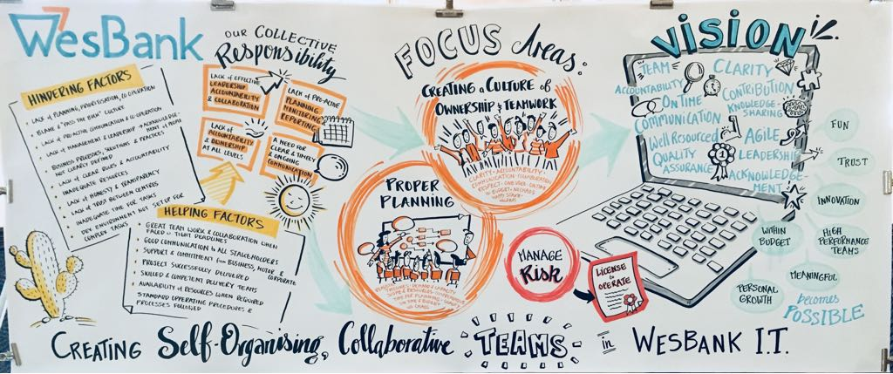

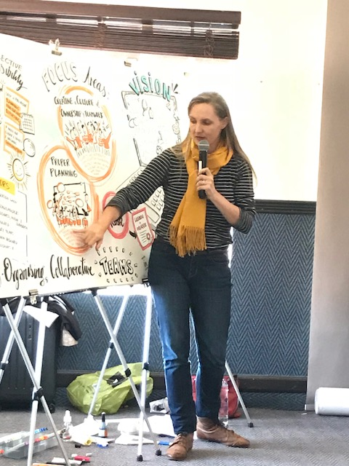

**Closing Round of Appreciation.**

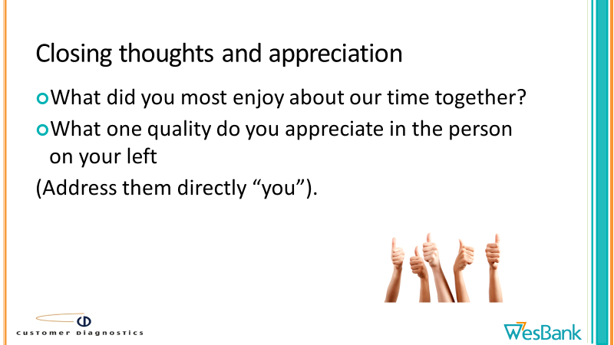

**Closing by Edwin**

Thanks to everyone for your time and commitment. Thank you to Alan & Team.

Thank you to Sonja, we have a beautiful graphic that we can take back to the office for us to reflect back on.

Workshop closes for the day

**Annexure A**

**Leader's responsibilities for inefficiencies & problems**



1. Lack of effective leadership accountability & collaboration
   1. Leaders need to LISTEN!
   2. Lack of direction, involvement & accountability from executive leadership that filters down to the team
   3. Breaking walls between teams, functions & businesses
   4. Breaking hierarchies
   5. No consequence management
   6. Lack of leadership collaboration & unity
2. Lack of pro-active planning, monitoring & reporting
   1. Insufficient planning
   2. Planning (resource constraints)
   3. Lack of effective planning
   4. Lack of continuous monitoring
   5. We did not resolve conflicting priorities
   6. Mismatch between demand & delivery (capacity)
   7. Teams need to be involved from inception
   8. We did not manage the project proactively to avoid crisis mode
   9. Better management
   10. Lack of planning & tracking
3. Lack of accountability & ownership at all levels
   1. People are not taking initiative to speak out
   2. Lack of personal accountability
   3. Clarity on roles and responsibilities
   4. Lack of ownership
   5. Accountability & ownership
   6. Learning from mistakes and taking action
4. A need for clear timely & ongoing communication
   1. Clear timely & ongoing project communication
   2. Information dissemination
   3. Lack of communication
   4. Lack of communication

Annexure B

Vision from Prework by delegates

|  |  |  |
| --- | --- | --- |
| **Code** | **1. In 3 to 5 years, imagine a world where WesBank IT were being consistently praised for our project capability (I.e. the recent difficulties experienced on the Governance and Regulatory projects would never happen).** | **Number** |
| A | Each team member is clear of their contribution in the success of a project and takes personal accountability for their part in the TEAM | **24** |
| B | All requirements and scenarios are understood by everyone involved and we are ready on time for each release and we meet release timelines (realistic) with quality deliverables- We are trusted by business | **23** |
| C | We raise and communicate delivery risks ahead of time | **7** |
| F | We share knowledge and skills between teams | **3** |
| H | There are dedicated and adequately resourced project teams assigned to projects | **5** |
| K | Compliance projects are centralised at WesBank group level for delivery. | **1** |
| L | We will have multiple QA environments to test Compliances, Daily, Weekly and Release changes | **1** |
| M | There is robust Quality Assurance measures in place, to ensure that the best work is done prior to the next ‘gate’ | **1** |
| N | The banks It infrastructure enables a more agile delivery method, to ensure that we deliver faster | **2** |
| Q | Leadership is supportive and takes ownership | **3** |
| S | People are acknowledged for their hard work and dedication | **1** |
| X | Other | **9** |

|  |  |
| --- | --- |
| **Code** | **1. In 3 to 5 years, imagine a world where WesBank IT were being consistently praised for our project capability (I.e. the recent difficulties experienced on the Governance and Regulatory projects would never happen), provide 2 to 4 descriptions of what will exist with regard to the way we will be working. Put your answers in the present tense, as though happening now.** |
| A | Each team member is clear of their contribution in the success of a project and takes personal accountability for their part |
| A | Understand that we are one team |
| A | Team that help each other – there is no, its not my job |
| A | There is no us and them within Corporate IT, we are all one team and we are there for each other |
| A | Each team member takes pride and is accountable of their deliverables. |
| A | There is a sense of urgency from all team members, and not just a selected few |
| A | People truly live by the core values of WesBank (We strengthens me, I get better and better, My word is my bond, My work is my signature) |
| A | Team members are held accountable for their non-deliverables |
| A | Excellent collaboration amongst delivery teams |
| A | People take ownership of the delivery from start to finish |
| A | Everyone is eager and participates actively in what needs to be done. |
| A | Everyone knows the implications of non-compliance and puts in extra effort where required to help the bank comply. |
| A | All teams work together for a common goal |
| A | There will be transparency in all that is done to achieve the goals |
| A | A team which understands and know what is required of each other |
| A | a. All members understand the objective of the project and what the expectations are known. |
| A | Clear identification of roles and responsibilities |
| A | People must accountable for their actions |
| A | We deliver as one IT team and understand that we only win as a team and not individuals |
| A | There is open communication, accountability and honesty |
| A | Each delivery team is accountable for their deliverables |
| A | b. Stakeholders are notified on time and convened to clarify their responsibilities. |
| A | Create a sense of urgency and make that part of everyone’s job |
| A | Everyone will know what, and who is responsible for delivery, especially when different systems integrate with each other |
| B | We are ready on time for each release and we meet release timelines with quality deliverables |
| B | We are clear of the impact to FirstRand if compliance timelines are not met and we are committed meeting all compliance deadlines |
| B | Strict timelines that is adhered to |
| B | Corporate IT deliver the right solution — no more, no less. |
| B | Corporate IT deliver without sacrificing quality or speed. |
| B | Corporate IT has a reputation of delivering projects on time |
| B | There is enough time to test solutions |
| B | Projects don’t come to the project space with deadlines already in place. |
| B | Proper timelines will be communicated and planning will take place long in advance |
| B | All requirements and scenarios will be understood by everyone involved |
| B | We have a single objective |
| B | Delivery of working software is the measurement of success, not individual team success |
| B | The project timelines are realistic. |
| B | Projects with already set timelines, without the project team having been consulted are not accepted |
| B | Plan better and concentrate on customer focus and service |
| B | Business will always be more comfortable with Corporate IT (in house) delivering on projects. |
| B | Corporate IT will be able to gain business trust and be able to advise for business what will work better for them. |
| B | The documentation is clear and well informed to do the task |
| B | The importance and urgency of regulatory projects is understood by all IT stakeholders |
| B | All teams have a shared vision of what needs to implemented in terms of regulatory solutions across the bank. |
| B | Clear business requirements |
| B | No scope creep, but this is usually because of unclear business requirements |
| B | No unrealistic expectations are placed on the delivery teams. |
| C | We raise delivery risks on time before IT EXCO probes |
| C | If a FirstRand decision is made; all communication is sent to all teams informing them of possible changes which could impact solutions being developed. This proactively happens as news are shared with the WesBank Product House. |
| C | Honest feedback is provided by the project members |
| C | The team members provide honest and early feedback when encountering problems. |
| C | Team members highlight issues immediately when such issues are identified |
| C | Transparency is vital between players |
| C | Communication has an enormous role to play |
| F | Corporate IT deliver, learn, and repeat, quickly |
| F | Knowledge and innovative solutions are shared across teams. |
| F | Sharing of skills is important to be able to work in a team environment |
| H | There are dedicated project teams assigned to projects, especially compliance projects. |
| H | Corporate IT is adequately resourced to deliver on project demand. |
| H | There will be a person who knows how all the systems integrate with each other, and has time available for the teams |
| H | The roles of the team is in a good balance to do any big project. |
| H | There are sufficient resources to get the work done. |
| K | Compliance projects are centralised at WesBank group level for delivery. |
| L | We will have multiple QA environments to test Compliances, Daily, Weekly and Release changes |
| M | There is robust Quality Assurance measures in place , to ensure that the best work is done prior to the next ‘gate’ |
| N | The banks It infrastructure enables a more agile delivery method, to ensure that we deliver faster |
| N | The banks systems are modernised and promote innovation and change |
| Q | Leadership is supportive and taking ownership |
| Q | Management listens to the needs of the project teams |
| Q | IT Management commits to realistic deadlines after consulting with team leads to assess workload |
| S | People are acknowledged for their hard work and dedication |
| X | Enterprise Architecture is more visible to provide the baseline architecture and target architecture especially where there are multiple systems interfaces. |
| X | There is less tick box governance and quality is built into the whole process |
| X | We work in a safe environment |
| X | The team knows and understand the change management processes. |
| X | Corporate IT delivery team (BA, SA, Dev, Testing and PM) is self-organized |
| x | Everyone within Corporate IT is free and can talk to anyone about anything. |
| x | Apply the Agile implementation methodology where possible instead to following a waterfall method all the time. |
| x | Co-operation and building relationships between external teams is very important, i.e. IT, change control, server admins, DBAs, etc. |
| x | Teams excelling in specific areas for example ‘Architecture’; provides guidance and looks at solutions holistically. This provides all teams with guidance on individual solutions in specific areas to tie in with WesBank group solutions. |

Annexure C

Hindering Factors from Prework by delegates

|  |  |
| --- | --- |
| **Code** | **Reflecting on recent Governance and Regulatory projects, in your view, what were the 3 to 5 major internal factors that most hindered or prevented the smooth, friction-free delivery of project goals? Try and identify and highlight the root causes of the problems that we experienced.** |
| **A** | **Lack of clear roles and accountability** of people, disciplines / functions on the project |
| **B** | **Lack of pro-active communication and co-operation** (to ensure that everyone had the context and information they needed to do their work - including between Motor and Corporate) Use of WhatsApp and Email |
| **C** | **Ineffective planning, prioritisation and control of the project**, especially with changes in scope. |
| **D** | **Lack of honesty and transparency** |
| **D1** | **A blame / pass the buck attitude and culture / Couldn't care less attitude => A lack of accountability** |
| **E** | **Lack of trust and transparency** between the two centres (Linked to a blame culture) |
| **F** | **Inadequate time for testing?** |
| **G** | **The dev environmen**t is not set up for complex project delivery |
| **I** | **Lack of management and leadership** exacerbated by parochialism / turf protection / lack of appreciation for people who did go the extra mile |
| **J** | **Inadequate resources** to do the work (linked to ineffective planning..) |
| **L** | **Business processes, solutions and practices were not clearly defined &/or followed** |

|  |  |
| --- | --- |
| **Code** | **Reflecting on recent Governance and Regulatory projects, in your view, what were the 3 to 5 major internal factors that most hindered or prevented the smooth, friction-free delivery of project goals? Try and identify and highlight the root causes of the problems that we experienced. (Please be as descriptive as possible so that a third party will understand what you mean). E.g. 1) The managers are not co-operating with each other and are protecting their turf. 2) People are not engaged and are dissatisfied with their jobs.** |
| **A** | Unclear accountability in managing project risks between project managers, QA manager, delivery manager, development managers |
| **A** | Unclear roles and accountability in UAT. Business analyst and PMs. What is the Project manager accountable for? BA accountability, QA accountability? Development? |
| **A** | Unclear accountability  of architecture team if any in solution design |
| **A** | There were too many people to answer to.  There should be one person that should manage the delivery and that person should be constantly updated.  If anybody wants a status update then they should consult  the correct person. |
| **A** | People don’t understand the criticality of the role they play and therefore real consequences of non-performance |
| **A** | Have change management and training team available to support projects, instead of the project delivery team having to execute change management activities. |
| **B** | Lack of pro-active risk communication and management |
| **B** | There are a lot of departments which need to be communicated on with the changes and not all departments are always communicated with each other |
| **B** | People were not cooperating and there was no face-to-face communication; everything was done on email and towards the end on WhatsApp |
| **B** | Communication is not being practiced from top to bottom. Between managers and developers |
| **B** | A lack of a proper communication plan to ensure all stakeholders are kept up to date on the project even when at a specific point they are not involved |
| **B** | Initially , there was miscommunication between the teams involved by the time they tried to fixed it was a little bit too late, thus led to teams working overtime to try and meet deadlines |
| **B** | As FirstRand news or memo changes occurs, teams are not proactively informed, often changes have to change solutions mid development, causing delays in delivery. |
| **B** | Two centres of delivery (Corporate and Motor) always pose a challenge to the delivery, as one team always appears to certain information and decisions than the other. |
| **B** | a. When people/stakeholders do not understand the background and objectives of the project there usually are confusions on deliverables that lead to delays in the project. |
| **B** | The users who conducted user acceptance testing did not fully understand the changes or the reasons for the changes. |
| **B** | Enterprise Architecture must be more visible. |
| **C** | Scope creep |
| **C** | Timelines have to be reasonable for everyone to do their work. Rushing and seeing how things go, does not work |
| **C** | Late changes need to be motivated and scrutinised as this will impact delivery times |
| **C** | Scope creep – somethings were thought to be negligible which ended up impacting the delivery |
| **C** | The priority is not clear |
| **C** | Too much planning theoretically and not enough doing |
| **C** | Opposing priorities among PMO’s could delay delivery. |
| **C** | Upper management making promises to when these changes will be delivered, without knowing the complexities of the actual changes |
| **C** | It is not clear the priorities of the tasks |
| **C** | Too much to do, too little time |
| **C** | The dead line and the amount of work required creates pressure as not all players are involved until the deadline looms |
| **C** | Management dictates timelines from EXCO to the project team |
| **C** | Unnecessary effort and time to put the solution into business |
| **C** | Business need to understand at an early stage how their business process may be affected because of regulatory changes |
| **C** | Gaps in requirement |
| **D** | Not being honest, when one didn’t finish their task |
| **D** | Project members were not honest. |
| **D** | Lack of honesty and transparency, with regards to ones capability to deliver within a specific time. People wait until the last minute, before they say they are struggling with a solution. |
| **D** | Team members are not transparent about their own deliverables in terms of timelines, effort required to deliver |
| **D1** | Lack of accountability |
| **D1** | Accountability is an issue |
| **D1** | Pass the buck attitude |
| **D1** | Some team members just disappear |
| **D1** | Environment of blame not teamwork |
| **D1** | Not all the team members were operating in crisis mode, once it was declared. |
| **D1** | People are not engaged and are dissatisfied with their jobs |
| **D1** | Lack of ownership for own work hurts the projects. |
| **D1** | Sense of urgency was lacking to some of the team members |
| **D1** | Some team members just didn’t care – team members refusing to play their part |
| **D1** | Lack of collaborative spirit – us and them attitude prevail |
| **D1** | People are unhappy about certain things and end up taking it out on the job |
| **D1** | Being territorial and not accepting other people’s advice makes things difficult. |
| **E** | Teams across Motor and Corporate work separately, a lack of communication sometimes causes teams working on the same thing at the same time / working on contradicting solutions. |
| **E** | Lack of trust and transparency between the two centres (Corporate and Motor). |
| **E** | Competition between businesses. There is no collective approach. Where one project manager was advancing further, their counterpart would try to put impediments in the project/programme usually sends more than one person to do the same this. This is a waste of time and has the potential to create conflict or confuse other stakeholders. |
| **E** | The different departments are not being transparent in order to facilitate the important changes |
| **F** | Testing |
| **F** | Testing and the entire project team is not given enough time to deliver the project. |
| **G** | We need a working Dev environment, so Dev do not have to do Unit Testing in QA |
| **G** | The development environments are not geared up for complex project deliveries |
| **I** | Lack of leadership |
| **I** | Management provides incorrect feedback to the executive to avoid looking like they do not know what happening. It is good to sometimes tell the person you do know and you will provide the status later. |
| **I** | The managers are not co-operating with each other and are protecting their turf |
| **I** | Management neither listens not take remove blockers for the smooth implementation of the project |
| **I** | Some managers protecting their team members – i.e my resource is not available, even though it’s all hands on deck – indicating that the involvement of all members of a team is required |
| **I** | Project managers should visibly oversee work coming from the different segments of IT |
| **I** | There is no consequence management for those that are not committed to doing their work |
| **I** | Furthermore, people that willingly performed other roles in addition to their own, were not acknowledged by anybody for it.  This kind of makes a person feel that this is a thankless job even if you constantly go the extra mile. |
| **J** | Lack of Developers |
| **J** | Lack of delivery resources |
| **J** | There was insufficient resources available.  Example, people had to play other roles to get this project delivered.  It is good that people were prepared to do this, however if we had the resources, we could have delivered much faster. |
| **J** | Lack of resources |
| **J** | People take on too many responsibility and lose focus on the critical projects |
| **L** | Architecture teams not providing holistic solutions / solutions not matching project goals. |
| **L** | Basic technical practices lacking (TDD, Source Control, Automated deployment) |
| **L** | Fixed practices in place |
| **L** | Process (in?)consistencies |
| **L** | Processes are not clearly defined |
| **L** | Business system are not properly documented |
| **L** | Unfortunately I was not part of any of the project, but what I have seen on other projects not everybody gets involved with the project throughout the SDLC (lot of red tape). |

Annexure D

Helping Factors from Prework by delegates

|  |  |
| --- | --- |
| **Code** | **3. Reflecting on the Governance and Regulatory projects, what were the 3 to 5 major internal factors that most helped us on those projects, that we will want to repeat in future projects?** |
| **A** | We had support and commitment from Business and Motor and Corporate IT Exco |
| **B** |  |
| **C** | The skilled and competent delivery teams |
| **D** | Great teamwork and collaboration (with personal sacrifices) especially when faced with tight timelines / pressure |
| **E** | Availability of resources when required |
| **F** | Good communication to all stakeholders (e.g. WhatsApp for timely feedback and comms). |
| **H** | The project requirements were successfully delivered |
| **I** | Standard Operating procedures and processes were followed. |
| **X** | Other |

|  |  |
| --- | --- |
| **Code** | **3. Reflecting on the Governance and Regulatory projects, what were the 3 to 5 major internal factors that most helped us on those projects, that we will want to repeat in future projects? E.g. 1) We did deliver the project goals Note that this is not what should be done to help the project, but what actually exists now/then.** |
| **A** | IT EXCO involvement and drive in issue resolution |
| **A** | Business support and commitment |
| **A** | Support from Motor IT and Change Management and Release Senior Management |
| **A** | Corporate IT management support and involvement when required |
| **A** | Priority given |
| **A** | Motor’s involvement (Gordon) fast-tracked the deployment of the solution. Future plan is to involve the implementation stakeholders (DBAs, WebLogic) ahead of time. |
| **A** | Business have a good understanding of the complexities. |
| **C** | Skilled and competent delivery teams ( BAs, Developers, Testers) |
| **C** | Sharing knowledge by experienced team members is vital (Is this a need to have or what was actually present??) |
| **C** | An effective project team to coordinate all teams for delivery |
| **D** | Great teamwork |
| **D** | When it is all hands-on deck, some team member go extra mile to solve the problem and forget about their title and role |
| **D** | Good Collaboration |
| **D** | Collaboration |
| **D** | A team mindset to get the changes prioritised and completed, even if it means working late hours |
| **D** | Certain individuals took charge and were willing to assist in other domains, in order to get the job done |
| **D** | There was support from some of the team members who kept the team motivated |
| **D** | There was a high degree of collaboration amongst the team members, where the team put in an extra effort and worked overtime when they were needed to. |
| **D** | The people worked as a team and there where workshops done to ensure the process was smooth |
| **D** | When required all team members pulled together to get things done which was great |
| **D** | When the team pulled together we were able to achieve the goals |
| **D** | Teamwork between teams is good, i.e. shared responsibility |
| **D** | Working tirelessly, and together, to meet the deadline |
| **D** | Team members willing to make sacrifices for the team |
| **D** | Commitment and taking your work serious |
| **D** | We have individuals that are willing to go beyond their roles to get the common goal achieved |
| **D** | Collaboration between Motor ad Corporate team, especially when faced with tight timelines |
| **D** | Team work, when we have to work under pressure to deliver |
| **D** | Work extra hours to meet deadlines. |
| **E** | Availability of Motor IT resource when needed |
| **E** | Manage projects better ito allocation of resources (this sounds like what is needed, not what was present) |
| **E** | The allocation of resources to regulatory projects were well defined and managed. |
| **F** | Good Communication |
| **F** | Creating a communication channel (WhatsApp) to provide timely feedbacks. |
| **F** | Creation of the WhatsApp to micro manage the set activities |
| **F** | A WhatsApp group chat was created in order to improve the communication amongst the team members |
| **F** | Regular communication to stakeholders helps. |
| **F** | Promote efficient communications |
| **F** | Main stakeholders were kept in the loop and notified of the problem |
| **F** | Where delays occurred, all stakeholders’ expectations were well managed and everyone understood exactly when implementations would occur. |
| **H** | Requirements successfully delivered |
| **H** | Honouring our commitments helps progress and highness interest of stakeholders |
| **H** | The projects that were delivered was successfully implemented and signed off by all stakeholders with good feedback. |
| **H** | The projects were delivered on time, so that means we do have the delivery capability |
| **I** | Good knowledge of business processes. |
| **I** | Standard Operating Procedures of future process changes were properly defined, assisting with project goals immensely (Defined by Process Teams). |
| **I** | Release management support and drive in co-ordination |
| **I** | Enough Testing |
| **X** | Detailed planning helps. |
| **X** | The two changes were deployed under pressurised and unrealistic timelines |
| **X** | Change of attitude |

WORKSHOP designed and FACILITATED BY

****™

**Alan Kirschner**

**Customer Diagnostics (Pty) Ltd**

Tel: +27 (0)11 465 5182

Fax: +27 (0)86 648 2068

Mobile: +27 (0)82 891 4268

Email: alan@customerdiagnostics.com

Web site:   www.customerdiagnostics.com

PO Box 899, Fourways, Sandton, 2055, South Africa